**Index**

|  |  |
| --- | --- |
| **Experiments No** | **Experiments Name** |
| 1 | Create a Database table with the following columns e.g.(Employee_ID, Name, Age, Department, Skill, Pay_rate) |
| 1.1 | Insert Data into table at least 5 persons. |
| 1.2 | Fetch all the data from the following table. |
| 1.3 | Update any person’s data from the following table. |
| 1.4 | Delete any person’s data from the following table. |
| 1.5 | Fetch data individually only whom person draw Highest & Lowest pay_rate . |
| 2 | Create a table at with the following columns e.g. (Customer_Name, City, Bank_Name, Branch_Name, Account_Type, Salary). |
| 2.1 | Insert Data into table at least 5 persons. |
| 2.2 | Show data whom person lives at certain place. |
| 2.3 | Show the customer information where account type will be same. |
| 2.4 | Show data whom customer gets salary 15000 – 20000. |
| 2.5 | Show data whom customer data is null. |
| 3 | Make an Employee database report in Microsoft access. |
| 4 | Design a form on access as name of Customer Table information. |
| 5 | Design an ER diagram on EVM system in Bangladesh. |
| 6 | Create the table in Microsoft in Microsoft Access on EVM system in Bangladesh. |
| 7 | Design an ER diagram on Online Bus ticket reservation system in Bangladesh |
| 8 | Design an ER diagram on E-commerce. |
| 9 | Design an ER diagram on E-book system. |

Experiment No:1

Experiment Name: Insertion data of 5 people into a table where remains following columns e.g.( Employee_ID, Name, Age, Department, Skill, Pay_rate) and Fetching them.

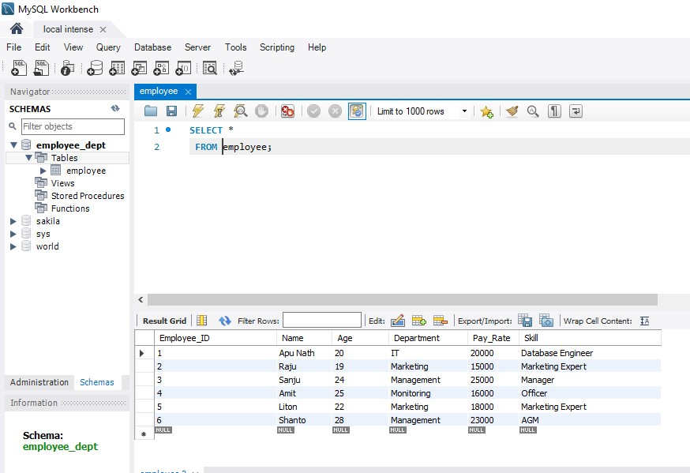

Experiment Name: Update any person data from the following table.

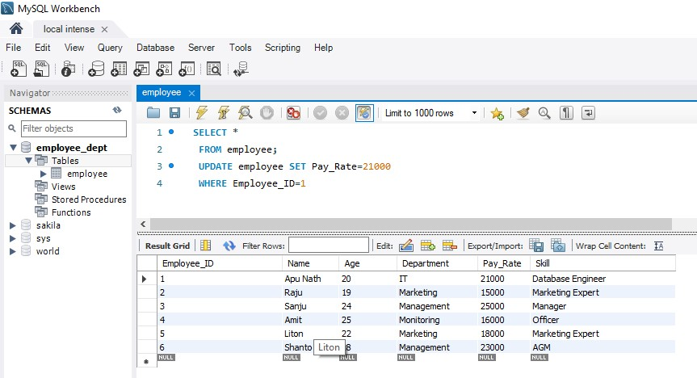

Experiment name: Delete any person data from the table.

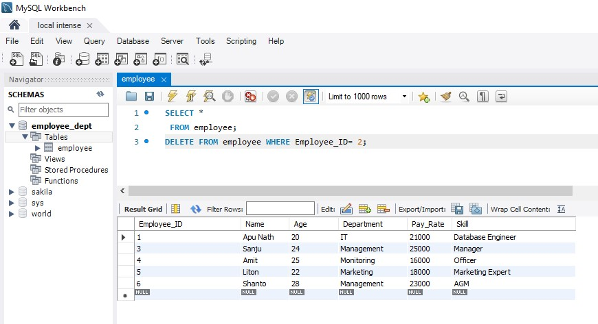

Experiment name: Fetch data of the person who draw Highest pay_rate.

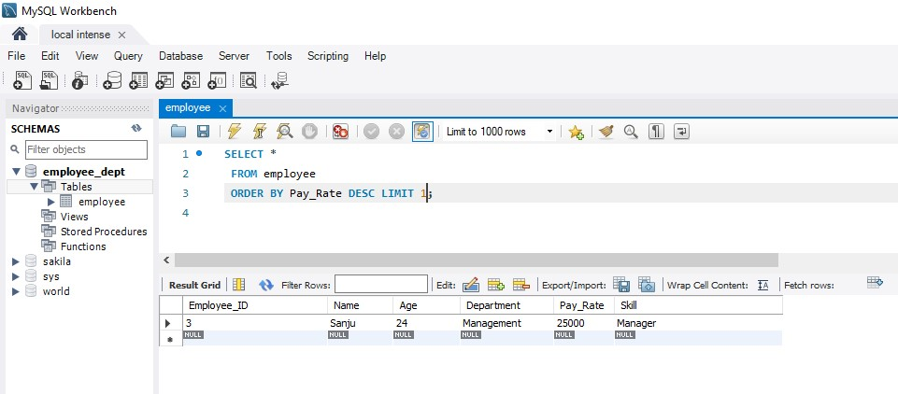

Experiment name: Fetch data of the person who draw the lowest pay_rate.

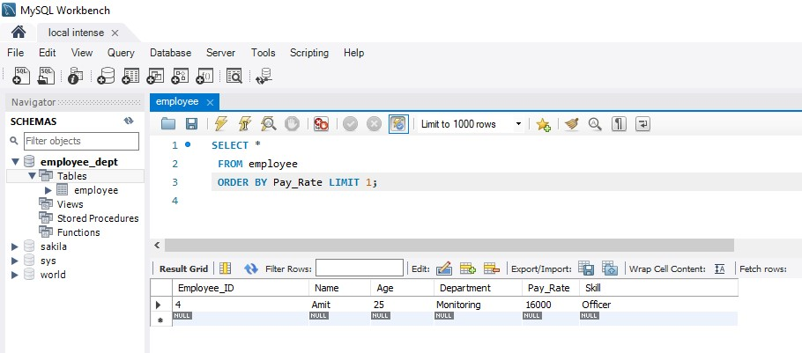

Experiment No: 2

Experiment Name: Insert data of 5 persons in a table where will be the following columns e.g.(Customer_name, City, Bank_name, Branch name, Account_type, Salary).

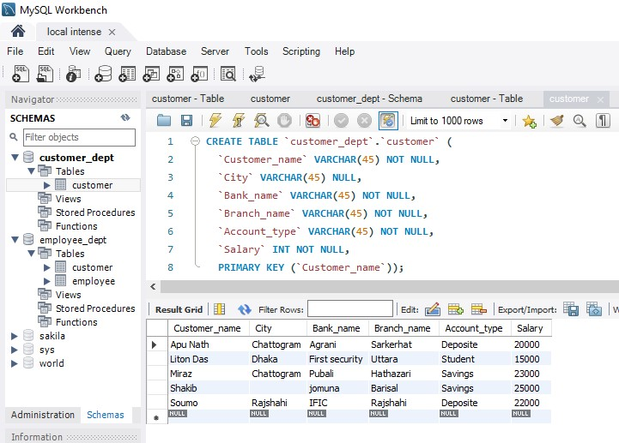

Experiment Name: Show data whom person lives at certain place.

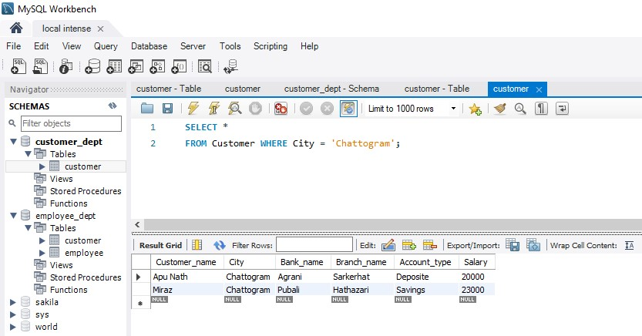

Experiment name: Show data of customer information where account type will be same.

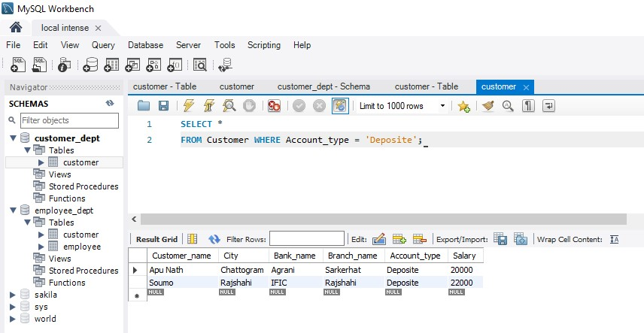

Experiment Name: Show data whom customer gets salary 15000-20000.

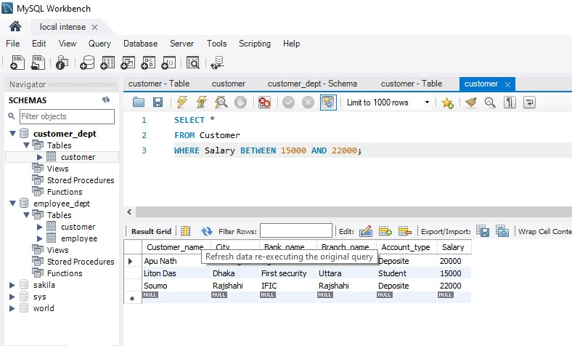

Experiment Name: Show data whom customer data is null.

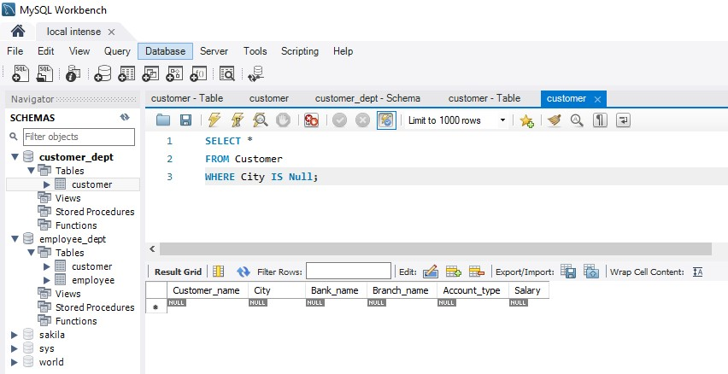

Experiments No: 03

Experiments Name: Make an Employee Database report on Microsoft Access.

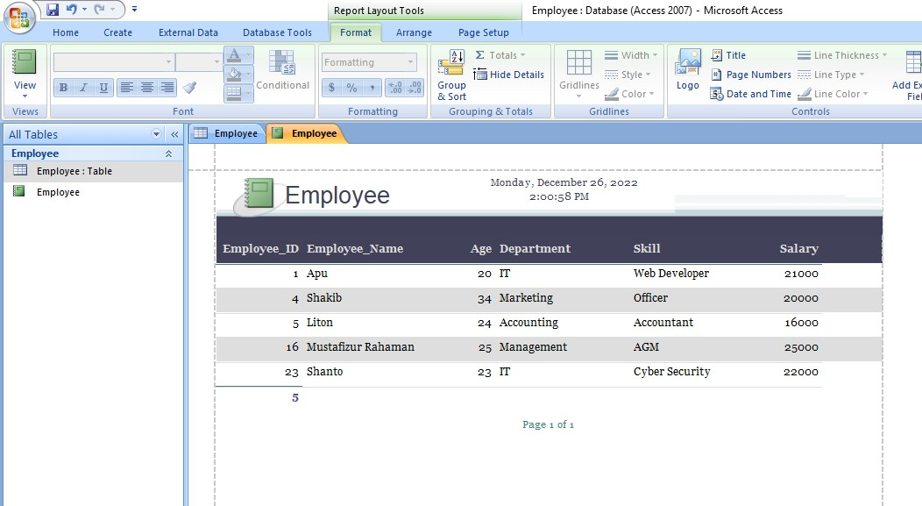

------- 0 -------

Experiment No: 04

Experiment Name: Design a form on Microsoft Access as a name of Customer information.

